 | 15.1.3 Editors - Movie Clip Editor - Header - View Menu
Table of content
Movie Clip Editor Modes 2
View Menu in Tracking mode in Clip sub mode 2
Toolbar 2
Sidebar 2
Adjust Last Operation 2
Frame Selected 2
View All 3
View Fit 3
Center View to Cursor 3
Zoom In 3
Zoom Out 3
Fractional Zoom 3
Pie menus 3
View Menu in in Tracking mode in Graph sub mode 3
Frame Selected 3
Frame All 3
Zoom In + Zoom Out 3
Pie menus 4
View Menu in in Tracking mode in Dopesheet sub mode 4
Frame All 4
Zoom In + Zoom Out 4
Area 4
Horizontal Split 4
Vertical Split 4
Duplicate Area into New Window 4
Toggle Maximize Area 4
Toggle Full screen Area 5
Close Area 5
Pie menus 5
View Menu in Mask mode 5
Toolbar 5
Sidebar 5
Adjust Last Operation 6
Set 2D Cursor 6
Frame Selected 6
View All 6
View Fit 6
Center View to Cursor 6
Zoom In 6
Zoom Out 6
Fractional Zoom 6
Pie menus 6

Movie Clip Editor Modes

The Movie Clip Editor is three editors in one. And the Clip editor in mask mode looks also different. So we need to explain the content for all three editor types plus the Mask mode.
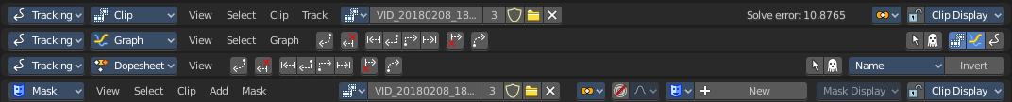

View Menu in Tracking mode in Clip sub mode

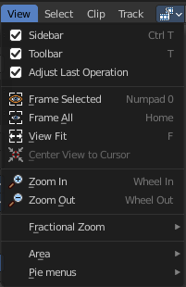
The View menu contains all View related tools.

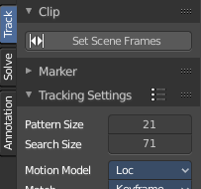
Toolbar
Shows or hides the toolbar at the left.

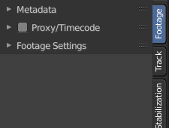
Sidebar
Shows or hides the sidebar at the right in the viewport.

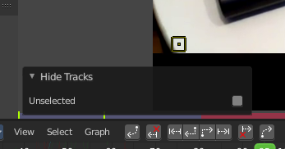
Adjust Last Operation
Shows the adjust last operation panel down left.

Frame Selected
Zooms to the selection.

View All
View all zooms in or out in the viewport until all selected objects are displayed fitting in the viewport.

View Fit
View all zooms in or out in the viewport to fit the current selection into the viewport.

Center View to Cursor
Center Cursor centers the view to the 2D cursor.

Zoom In
Zooms into the view.

Zoom Out
Zooms out of the view.

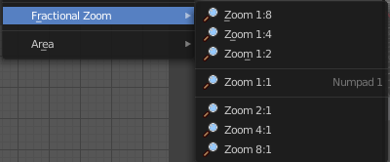
Fractional Zoom
A set of predefined zoom factors.

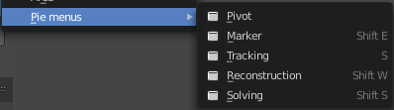
Pie menus
Lists the available pie menus, and gives you the ability to read the hotkeys and assign own hotkeys.

View Menu in in Tracking mode in Graph sub mode

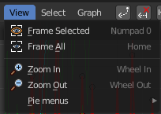
The View menu contains all View related tools.

Frame Selected
Centers the view at the current frame(s).

Frame All
Views all content, zoomed in to fit into the viewport.

Zoom In + Zoom Out
Zoom in and out in the viewport.

Pie menus
Lists the available pie menus, and gives you the ability to read the hotkeys and assign own hotkeys.

View Menu in in Tracking mode in Dopesheet sub mode

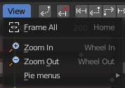
The View menu contains all View related tools.

Frame All
Show all content, zoomed to fit into the viewport.

Zoom In + Zoom Out
Zooms in and out in the viewport.

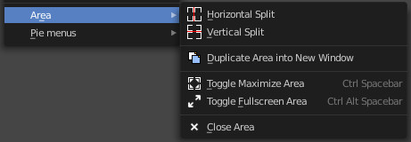
Area
This menu contains general view functionality. And exists in most other editor types too.

Horizontal Split
Splits the current view horizontally into two independent editor windows.

Vertical Split
Splits the current view vertically into two independent editor windows.


Duplicate Area into New Window
Duplicate Area into New Window makes the selected editor window floating. You can then drag it around at the monitor. It is not connected with the rest of the UI anymore.
A separated window cannot be merged into the main window again. You have to close it when not longer needed.

Toggle Maximize Area
Displays the editor maximized with menus.
To return from the maximized view press hotkey ctrl + spacebar. Or reuse the menu item in the area menu.

Toggle Full screen Area
Displays the editor maximized without menus.
To return from the full screen view press hotkey ctrl + alt + spacebar.

Close Area
Close the area window.

Pie menus
Lists the available pie menus, and gives you the ability to read the hotkeys and assign own hotkeys.

View Menu in Mask mode

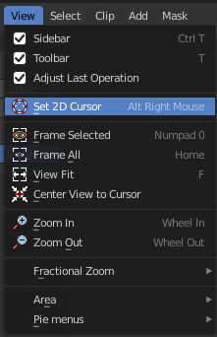
The View menu contains all View related tools.

Toolbar
Shows or hides the toolbar at the left.

Sidebar
Shows or hides the sidebar at the right in the viewport.

Adjust Last Operation
Shows the adjust last operation panel down left.

Set 2D Cursor
The 2D cursor is the center for mask creation and modification. Hotkey only tool! Please use the hotkey!

Frame Selected
Zooms to the selection.

View All
View all zooms in or out in the viewport until all selected objects are displayed fitting in the viewport.

View Fit
View all zooms in or out in the viewport to fit the current selection into the viewport.

Center View to Cursor
Center Cursor centers the view to the 2D cursor.

Zoom In
Zooms into the view.

Zoom Out
Zooms out of the view.

Fractional Zoom
A set of predefined zoom factors.

Pie menus
Lists the available pie menus, and gives you the ability to read the hotkeys and assign own hotkeys.

